Progress Report of Project  M:PR/E | Project No. : 2021 / 1067

Reporting Period: From Sept 2023 (month/year) to Feb 2024 (month/year)

Part A
Project Title: AI-Assisted Virtual Reality English Speaking Program for Secondary Students
Name of Organization/School: Center for Language Education, The Hong Kong University of
Project Period: From Sept 2023 (month/year) to Aug 2026 (month/year)

Part B
Please read the Guidelines to Completion of Progress Report of Quality Education Fund Projects before completing this part of the report.

Please use separate A4-size sheets to report the progress with regard to the following aspects:
- Project activity during the reporting period
- Project variation*, if any, during the reporting period
- Self-evaluation of project effectiveness with indicators and measures of effectiveness clearly stipulated
- Dissemination of deliverables and good practices, if any, and responses to such dissemination

Name of Project Leader: | ______Kasina Wong________ | Name of Grantee: | _______CLE, HKUST________
Signature: | _________________________ | Signature: | _________________________
Date: | _________________________ | Date: | _________________________

* For variations not covered by the terms of the Agreement, a separate written application should be submitted to the Quality Education Fund for prior approval.

* Progress Report of Project should be submitted via “Electronic Project Management System” (EPMS). Once submitted, these reports are regarded as already endorsed by the supervisor of the school/the head of the organization or the one who signed the Quality Education Fund Agreement for allocation of grant on behalf of the organization.
1st Progress Report (QEF Ref: 2021/1067)

Introduction:
This is a progress report providing an update on the QEF project from September 2023 to February 2024.
The purpose of the report is to outline the key activities and progress made during the reporting period, as well as any variations from the original project plan. It will report on project implementation, effectiveness of activities conducted, and dissemination of deliverables.
The main activities covered in this reporting period include staff recruitment for the project teams, setup of required accounts and systems, development of the first curriculum deliverable, and prototypes of the mobile application, learning management system and AI feedback system to support curriculum development based on the planned timelines. Any variations to the project scope or team composition will also be documented.

1. Project activity
According to the QEF proposal, the key activities for this progress report (Reporting period Sept 23 – Feb 24) includes the following information:

Activities | Progress Made and/ or Remarks
Sep 23 - Dec 23
- Staff recruitment for the project | Completed
- Service contract with Trumptech | Completed
- Project Account setup within HKUST | Completed
- Weekly meetings with the Curriculum Team, the VR & AI Team (Oculus software and AI Speech Recognition development), and Trumptech (Mobile Application and LMS development) | Completed – see appendix 5.3 for meeting details and topics discussed
- Curriculum Development (Deliverable 1) | One of the English speaking courses (i.e., the pronunciation course) was completed.
- VR & AI Feedback System Development (Deliverable 4) | The design of the AI speech recognition testing site was completed.
- LMS and Mobile Application Development (Deliverable 3 & 5) | The mobile application and LMS features discussion were ongoing.
Jan 24 - Mar 24
- Curriculum Development (Deliverable 1) | The design of the curriculum framework and other English speaking courses are undergoing.
- VR & AI Feedback System Development (Deliverable 4) | The internal testing of the AI speech recognition testing site is in progress.
- LMS and Mobile Application Development (Deliverable 3 & 5) | The development of the mobile application and LMS for UAT are current underway.

2. Project variation
  - Variation on participating schools:
    - These are the current participating schools:
      - Hong Kong Taoist Association Tang Hin Memorial Secondary School
      - HKMA David Li Kwok Po College
      - Li Po Chun United World College of Hong Kong
      - Good Hope School
      - Shung Tak Catholic English College
      - Christian Alliance College
      - HKSKH Bishop Hall Secondary School
      - SKH Tsang Shiu Tim Secondary School
      - St Louis School (newly joined school)
      - Carmel Bunnan Tong Memorial Secondary School (newly joined school)
  - Other schools:
    - These are the schools dropped out or with no confirmation:
      - CNEC Christian College (dropped out)
      - Fukien Secondary School (dropped out)
      - HKMLC Queen Maud Secondary School (no confirmation)

- There are NO other known variations required reporting in the stated period.

3. Self-evaluation of project effectiveness
Based on the activities listed in section 1: Project Activity, the project team would self-evaluate the current progress to be in good progress, with some unforeseen delays mainly related to the use of funds as follows.

Currently, the allocated funds are mainly used for staff costs (Budget Category: A. Staff) and paying the system and application development service fees to Trumptech (Budget Category: B. Services), while some equipment were placed too (Budget Category: C. Equipment). Other services expenses are not claimed yet the service deliverables have not been submitted.

The project team has spent a considerable amount of time in dealing with these non-development and research-related issues. It took some time to settle the service contract with Trumptech. Additionally, we have met the adminstrative constraint in claiming the service charge across internal departments (from HKUST VisLAB, Academy of Interdisplinary Studies). Therefore, although the development on our deliverables are in good progress, the unexpected administrative obstacles hinder the project team to fully concentrate only on the project development. To enhance our project effectiveness in the next reporting period, the project team will explore different possibilities with the support of QEF. Option 1: we will sort out the service contract with VisLAB via VisLAB outsourcing service to an external company, and the project team will work on establishing a service contract with that external company to formally establish a service contract; optional 2: we will investigate the possibility to request a budget virement to reallocate the service fee to increase the staff headcounts. The project team has considered the potential changes to other related items (e.g. overheading charges, etc) if adopting option 2 and will amend those items and have the new budget plan reflected in the new budget virement request form.

4. Dissemination of deliverables and good practices
The project team has presented the project to 15 seconardy school principals in a meeting within HKUST. One of those schools decided to parttake in our project and has become the 11th participating school.

The project team has been accepted to present in a language education conference. We will disseminate good practices based on this project in August 2024 (AILA 2024 - Kuala Lumper). Updates will be provided in the next progress report.

The project team will also begin to contact schools for piloting the prototype to collect users’ feedback. The feedback collected will be summarized in the next progress report.

Appendices
5.1 Appendix – Screenshots of the Mobile APP Prototype 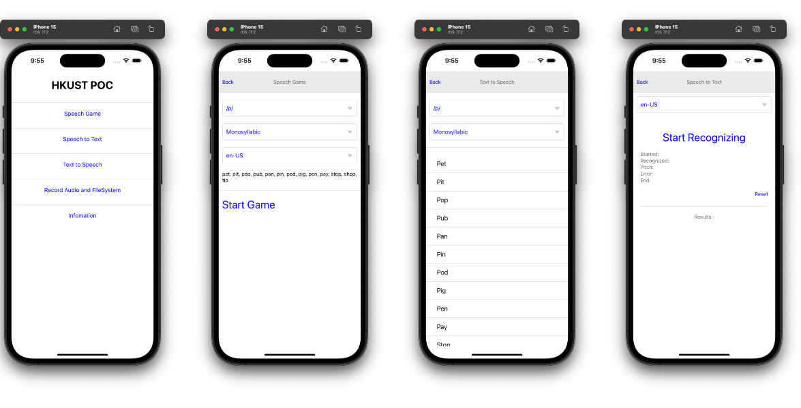
5.2 Appendix – Learning and assessment materials for English Speaking Course 1
5.2.1 Self-developed DSE English speaking practice
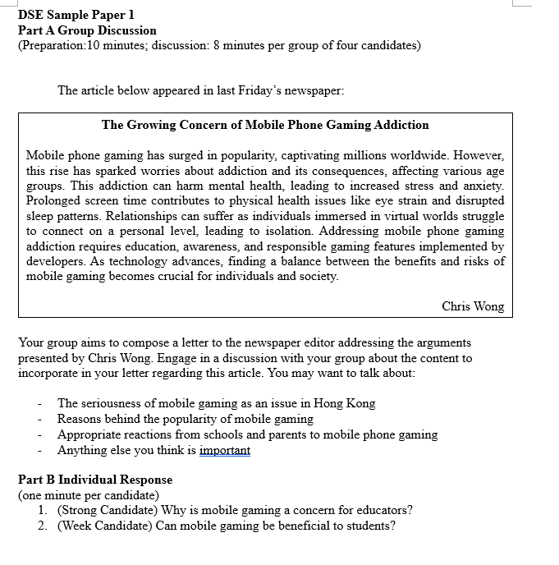
5.2.2 Video lessons on speech sounds in English Speaking Course 1

5.3 Appendix – Screenshots of the LMS Prototype
5.3.1 Modules and lessons layout on LMS for curriculum development use
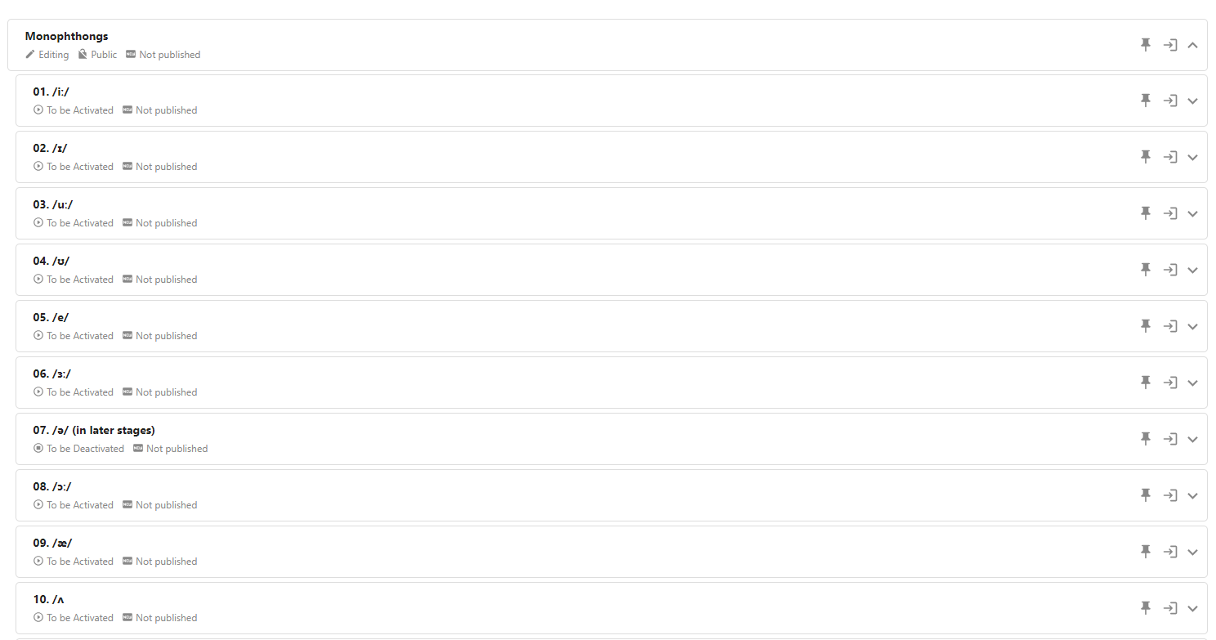

5.3.2 Lessons editing layout on LMS for curriculum development use

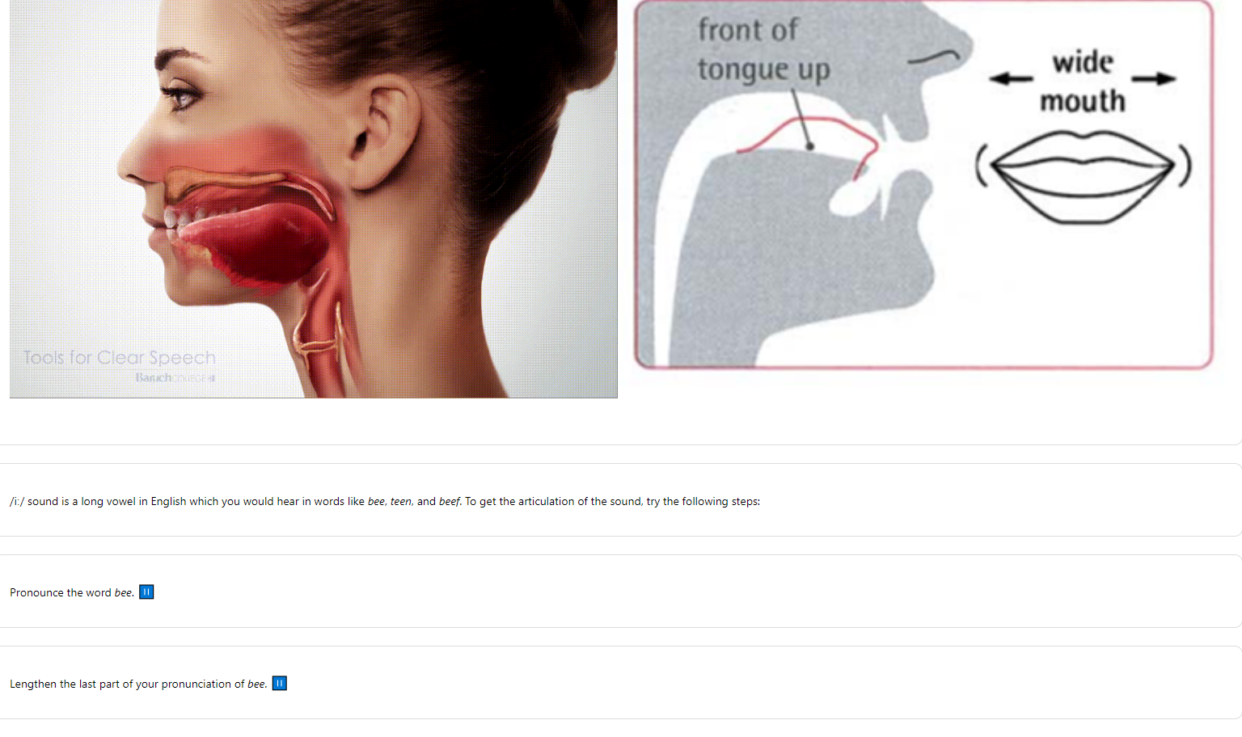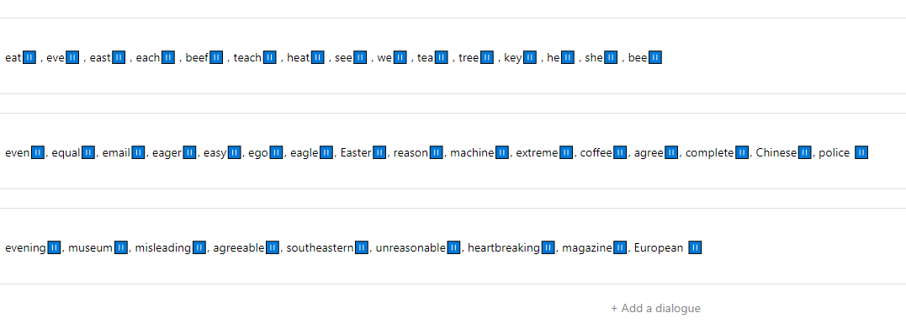
  - Meeting summary:
5.3.1 Curriculum team meeting
Activity
Date | Venues | No. of attendees | Activities
06/09/2023 | Online meeting | 2 | Discussion of the general design of vowel + consonant lessons
28/11/2023 | Online meeting | 2 | Discussion of the lists of minimal pairs
28/12/2023 | Online meeting | 4 | Discussion of the list of vowels + consonants covered  Discussion of the minimal pairs written and the ones to be written
04/01/2024 | Online meeting | 4 | Discussion of the preparation of DSE sample papers  Discussion of the minimal pairs written
12/01/2024 | Face-to-face meeting | 4 | Discussion of DSE papers  Discussion of the sample lessons to be prepared
23/01/2024 | Online meeting | 6 | Discussion of the lessons on the LMS system to be tested
26/01/2024 | Online meeting | 5 | Discussion of Synthesia videos to be generated  Discussion of the participating schools to be contacted
14/02/2024 | Online meeting | 4 | Discussion of the development of AI tutor scripts

    - VR & AI team meeting
Activity
Date | Venues | No. of attendees | Activities
12/10/2023  11 a.m. | Online meeting | 8 | Discussion of technical issues  - Survey of speech recognition API used in the prototype system for deliverable 2
09/11/2023  10 a.m. | Online meeting | 7 | Discussion of technical issues  - Design of the system  - System concurrency  - Delay of recognition API
23/11/2023  10 a.m. | Online meeting | 7 | Discussion of technical issues  - System design iteration
07/12/2023’10 a.m. | Online meeting | 8 | Discussion of technical issues  - Object detection for video recording  - Details for IRB application
04/01/2024  10 a.m. | Online meeting | 8 | Discussion of technical issues  - Object detection for video recording  - Issues about data protection
18/01/2024  10 a.m. | Online meeting | 8 | Discussion of technical issues  - Project milestone updating  - System deployment
01/02/2024  9 a.m. | Online meeting | 8 | Discussion of technical issues  - Project milestone updating  - System deployment

    - Mobile Application & LMS development meeting
Date | Venues | No. of attendees | Activities
9/10/2023 10:30am | Online Meeting | 7 | Project kick start meeting.  Discuss:  - Timeline  - Project infrastructure setup  - Development flow
12/10/2023  10:30am | Online Meeting | 4 | Project infrastructure setup  - Prepare pricing quotation from Azure and AWS
26/10/2023  11:30am | Online Meeting | 4 | Project infrastructure setup  - Cloud service comparison from 2 different ISP  Project specification document  - 1st draft of functional specification  - 1st draft of APP wireframe
31/10/2023  10:00am | Online Meeting | 4 | Project infrastructure setup  - Tendering process follow up (PURO)  Project specification document  - Gamification features
6/11/2023  12:30pm | Online Meeting | 4 | Project infrastructure setup  - Tendering process follow up (PURO)  Project specification document  - Research on mini-game for App
29/11/2023  10:30am | Online Meeting | 4 | Project infrastructure setup  - Final tendering process  Project specification document  - Finalizing project functional specification (learning_management_system)  - System wireframe review
4/12/2023  10:30 | Online Meeting | 4 | Project specification document  - 2nd Draft project functional specification (learning_management_system) (reviewing by CLE IT team)  System wireframe review
13/12/2023 | Signoff | 2 | LMS functional specification signoff
18/12/2023  10:30 | Online Meeting | 4 | Project infrastructure setup  - Azure Cloud service setup (SoftwareOne)  - Voice recognition research
28/12/2023 | Online Meeting | 3 | Adhoc meeting in Cloud service setup
4/1/2024  9:00am | Online Meeting | 8 | Project milestone update
8/1/2024  10:30 | Online Meeting | 4 | LMS features discussion.  - POC of voice recognition tool  PM workflow discussion  Project development platform subdomain application
15/1/2024  10:30am | Online Meeting | 4 | Discussion on LMS and APP  - Lesson structure  - Course structure
19/1/2024  2:30pm | Online Meeting | 3 | Project Setup training with AI/VR team.  (redmine and gitlab)
22/1/2024  10:30am | Online Meeting | 4 | Deliverable: LMS features walkthrough and feedback
29/1/2024  10:30am | Online Meeting | 4 | LMS walkthrough and training for curriculum team.  Project Setup training with curriculum team (redmine)
5/2/2024  10:30am | Online Meeting | 4 | App features discussion:  - New course structure

